

OFFICE OF THE PRINCIPAL
GOVT DEGREE COLLEGE PATTAN

NAAC Accredited
Baramulla, Kashmir-193121
www.gdcpattan.com Email: gdcpattan@yahoo.com Tel : 01954231244

No/GDCP/24/607-A Date: 29-06-2024
REPORT
Title: Lecture on Fundamental Duties under the banner Shikshit Bharat
Viksit Bharat Cell and NSS Wing of Government Degree College Pattan jointly organised a lecture on Fundamental Duties under the banner Shikshit Bharat on 01-07-2024. The event was moderated by Coordinator Viksit Bharat Cell Dr. Shahzadi Wufai Naw Bahar who welcomed the attendees and gave a brief outline of ViksitBharat@2047 flagship programme. The event was graced by the Principal of the college Dr. Nazir Ahmad Simnani, who during his maiden address to the students highlighted the importance of Fundamental Duties as a beacon guiding citizens of the country towards a harmonious, prosperous and productive relationship with their country and fellow citizens. The Principal emphasized on the significance of co-curricular activities for the holistic growth of students and the institution and urged that the students should show enthusiasm while actively participating in such activities. The event advanced with a comprehensive and captivating presentation by the subject expert Dr. Gowher Ahmad Bhat. He discussed the essence of Indian Constitution highlighting the importance of fundamental duties as a reminder to the citizens of India that in addition to the enjoyment of rights, they also have to perform certain duties towards their country. He further added that fundamental duties are a set of moral and ethical obligations that citizens ought to uphold towards their nation. The programme concluded with a vote of thanks proposed by Prof. Safeer Mukhtar Co-convenor Viksit Bharat Cell.

Glimpses of the event:
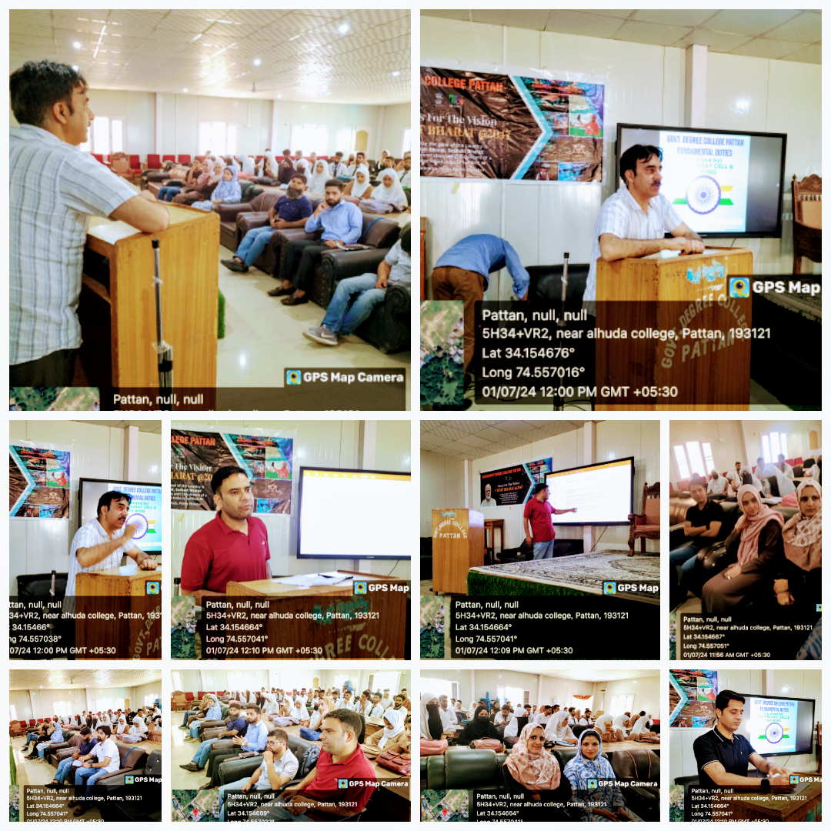
Submitted by
Dr. Shahzadi Wufai Naw Bahar
Coordinator
Viksit Bharat Cell

Copy to:
- Coordinator Viksit Bharat for record
- Convenor IQAC for record
- I/C Website for uploading on college website
- Office for record

